
Department of Artificial Intelligence and Data Science
24ADI306 DEEP LEARNING

Self Learning Assignment

Course Outcome(s): CO3
Bloom's Level: Apply & Analyze (K3–K4)
Topic: Exploring Word Representations: From Traditional Word Embeddings to Transformers
Objective: To explore traditional and neural word embedding techniques, understand including traditional vectorization, Word2Vec, GloVe, FastText, neural embeddings using TensorFlow and Keras, and contextual embeddings using Transformers. Visualize high-dimensional word embeddings to understand semantic relationships.
Task | Description
Traditional Word Embeddings | Study traditional text representation techniques such as One-Hot Encoding, Bag of Words and TF-IDF. Compare their characteristics and limitations.
Word Embeddings using TensorFlow and Keras | Explore the Keras Embedding layer and implement a simple text representation model using TensorFlow.
Word2Vec: CBOW and Skip-gram | Study both Word2Vec architectures. Implement either CBOW or Skip-gram and demonstrate semantic relationships between words.
Transformer-Based NLP | Explore contextual word embeddings using a pretrained Transformer model such as BERT. Compare static and contextual word representations.
Embedding Visualization | Use TensorFlow Embedding Projector to visualize word embeddings and identify semantic similarities and word clusters.

1. Techniques to Be Explored
Category | Techniques
Traditional text representation | One-Hot Encoding, Bag of Words (BoW), TF-IDF, N-grams
Frequency and matrix-based embeddings | Co-occurrence Matrix, SVD, LSA
Predictive word embeddings | Word2Vec (CBOW and Skip-gram)
Pretrained word embeddings | GloVe, FastText
Neural word embeddings | TensorFlow and Keras Embedding Layer
Contextual embeddings | ELMo, BERT, RoBERTa
Sentence embeddings | Sentence-BERT (SBERT), Universal Sentence Encoder (USE)
Embedding visualization | TensorFlow Embedding Projector, PCA, t-SNE, UMAP

2. Assignment Tasks
Task | Description
1. Literature Exploration | Study traditional, predictive and contextual text representation techniques. Prepare a comparative table of at least six techniques.
2. Word Embedding Implementation | Implement Word2Vec using CBOW or Skip-gram and experiment with GloVe or FastText using a sample text dataset.
3. Neural and Contextual Embeddings | Generate word embeddings using TensorFlow/Keras and explore a pretrained Transformer model such as BERT or SBERT.
4. Embedding Visualization | Visualize generated embeddings using TensorFlow Embedding Projector, PCA, t-SNE or UMAP. Identify semantic similarities and clusters.
5. Comparative Analysis and Report | Compare the selected techniques based on semantic representation, handling of out-of-vocabulary words, contextual understanding and computational requirements.

3. Experimental Tasks
Select a common text dataset and perform the following activities:
- Generate text representations using TF-IDF, Word2Vec and one additional embedding technique of their choice.
- Identify the five most semantically similar words for selected query words using cosine similarity.
- Examine how FastText handles rare or out-of-vocabulary words and how BERT represents a word in different contexts.
- Visualize the generated embeddings and interpret the semantic relationships between words.

References:
- Traditional Word Embeddings
  - traditional_word_embeddings.ipynb - Colab
- Word Embeddings​
  - Word embeddings | Text | TensorFlow​​
  - word_embeddings_lab.ipynb - Colab
- TensorFlow Word2Vec Tutorial
- TensorFlow Text and NLP Tutorials
- Gensim Word2Vec and FastText
- Hugging Face Transformers
- Tensorflow Embedding projector - visualization of high-dimensional data
- What Are Word Embeddings? | IBM
Assignment Submission
Submit a self-learning report containing a brief explanation of each technique, relevant implementation screenshots or Github/Colab notebook links, embedding visualizations and a comparative analysis of Traditional, Word2Vec and Transformer-based embeddings.
Expected Learning Outcome: Students will be able to distinguish between traditional, static and contextual word representations, implement neural word embedding techniques, and interpret semantic relationships through embedding visualization.

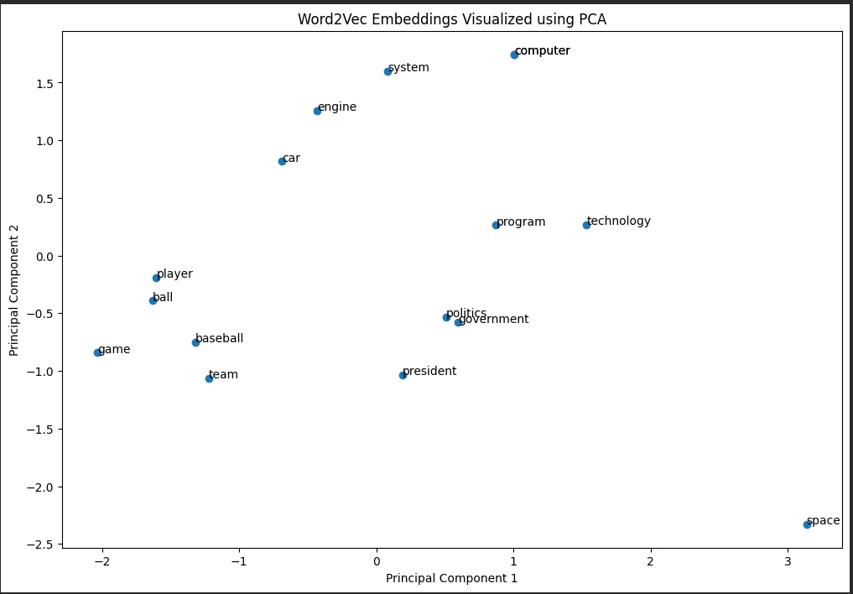

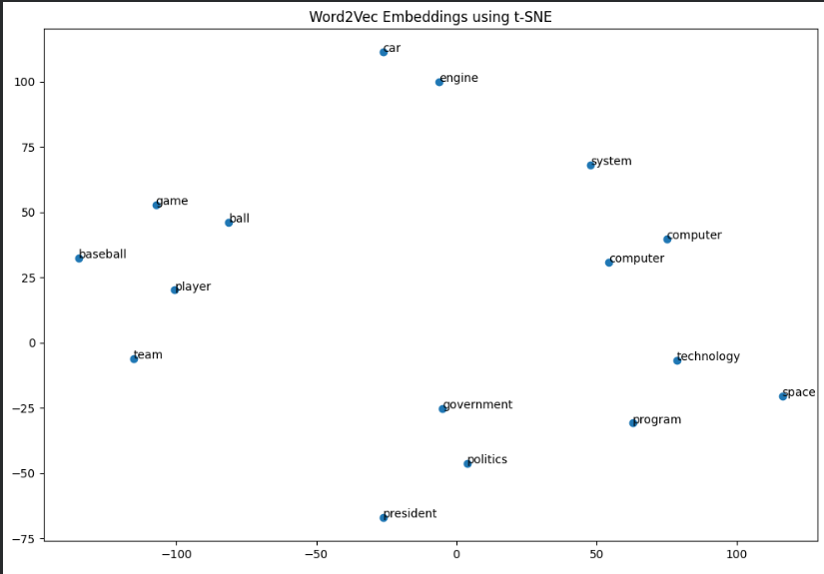

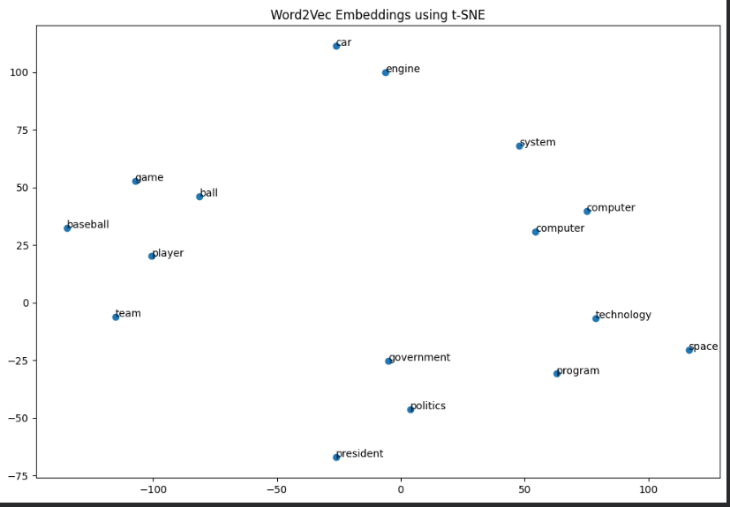

Colab link:

https://colab.research.google.com/drive/1O7ysaInpC0IWODVFHu8Ed3sEvMQQTqnt?usp=sharing

Deliverables:
• Jupyter/Colab Notebook
• Github Link/Source Code
• Comparison Table
• 5-6 Page Report

Assessment Rubric:
Criterion | Marks
Conceptual Understanding | 7
Implementation, experimentation analysis and visualization | 8
Performance comparison and Report | 5
Total | 20

